**Information:**

Interview conducted with Interviewee 10 (female; nurse)

26 minutes

Language spoken: Portuguese

Automatic transcription done with the software Happy Scribe, and checked by a coder.

Translations to the interviewee’s responses are provided in square brackets in grey.

**Follow-up to the survey on the use of machine translation in health contexts**

**Researcher:** Thank you again for accepting to participate in this interview. As you already know, this is a follow-up interview to the questionnaire on the use of machine translation in healthcare in the Netherlands. You replied to this questionnaire earlier this year. Let me start by reminding you that this interview is being recorded. The data collected will be anonymized and analyzed together with other participants’ data. The recording itself will never be published or shared, and it will be deleted as soon as it is transcribed and anonymized. You are free to request a copy of the transcription. In the interview itself, we will invite you to go over potential scenarios regarding the use of technology - specifically, machine translation like Google translate or any other translation system on your phone or device - in healthcare contexts, like when you receive an invitation letter to get vaccinated or when you go to the doctor, huisarts.  The goal is to understand how machine translation can be used and what are the main challenges or opportunities when using it. We aim to create free training for users of machine translation like yourself in order to better support communities in these situations. The scenarios that we will show you are fictitious. They are potential scenarios or stories. The focus is on what you think a person would do if they were in this situation. Discuss anything that comes to mind or that you would like to share. We just ask you not to share confidential information about yourself.  If at any point, during the interview, you feel uncomfortable and you want to pause the interview, please just let us know. We can rephrase the question or stop the interview altogether. You can leave at any point during this interview.

**Participant:** Okay.

**[STAGE 1 SLIDE 2]**

**Researcher:** I will start now by reading the first scenario that you can also see on the screen.“Two years ago, Maria moved to the Netherlands from Portugal. It was right amid the pandemic, and she moved to take up a position at a new company in Rotterdam. Maria is a native speaker of Portuguese, and she also speaks English. She has taken two Dutch courses online, so she understands and speaks rudimentary Dutch. For example, she can ask for a drink or have short conversations with neighbors, but not enough to feel fully comfortable speaking Dutch fluently in all situations. In 2021, she received a letter from the RIVM inviting him to get vaccinated against COVID-19. The letter is in Dutch.” What do you think about this case?

**Participant:** Eu penso que a mesma coisa já me aconteceu. Sim, foi exatamente assim, foi precisamente para... Sim, foi para ser vacinada contra o Covid. [I think the same thing has happened to me. Yes, it was exactly like that, it was precisely to... Yes, it was to be vaccinated against Covid.]

**Researcher:** What do you think Maria can do in this situation with the letter?

**Participant:** Pois, é assim, uma vez que ela tem dificuldades certamente com a carta em perceber holandês, lá está. O que eu fiz pessoalmente foi usar o Google Translate, neste caso a opção de usar a câmera que é muito mais rápido.[Well, since she certainly has difficulties with the letter in understanding Dutch, there it is. What I personally did was to use Google Translate, in this case the option to use the camera which is much faster.]

**Researcher:** If you receive a letter from the RIVM in Dutch, what do you do?

**Participant:** E sim, eu faria isso. É mais rápido porque traduz de uma vez tudo.[And yes, I would do that. It's quicker because it translates everything at once.]

**Researcher:** And did you use an app?

**Participant:** Eu usei a do Google Translate.[I used the Google Translate one.]

**[STAGE 2 SLIDE 3]**

**Researcher: “**Because the letter mentioned COVID-19 and vaccinatie, and Maria had been waiting for more information on when and how she could get vaccinated, it was very important for him to understand the letter completely and thoroughly in all its detail. She tackles this by trying to read the letter top to bottom, sentence by sentence. The letter is hard to understand. She does not know many of the words used, and she feels increasingly nervous.” Why do you think Maria feels this way?

**Participant:** Eu compreendo perfeitamente porque ela não está na sua terra. E é frustrante quereres perceber alguma coisa e não conseguires perceber completamente tudo. Eu percebo perfeitamente essa sensação.[I completely understand because she's not in her own land. And it's frustrating to want to understand something and not be able to fully understand everything. I understand that feeling perfectly.]

**Researcher:** Have you ever found yourself in a similar situation?

**Participant:** Imensas vezes.[Plenty of times.]

**Researcher:** What would you recommend Maria to do next?

**Participant:** Utilizar a app. Eu acho que sim, é a coisa mais lógica a fazer neste caso.[Use the app. I think so, it's the most logical thing to do in this case.]

**[STAGE 3 SLIDE 4]**

**Researcher: “**Maria decides to use Google Translate. She opens the app on her phone, and using the camera, she scans the letter. It is rather challenging.” How would you say her user experience with the app is?

**Participant:** Acho que não é, não é que seja difícil, acho muito fácil até usar a aplicação, só que o chato é que às vezes é preciso tirar uma boa foto, às vezes é preciso mais do que uma vez, ou às vezes precisamente por precisamente estar em formato numa carta ou uma foto que foi tirada por nós, às vezes a foto não fica muito bem e então as palavras traduzidas ou são muito mal traduzidas ou então não ficam muito bem e pronto são esses os problemas que eu encontro.[I don't think it is, it's not that it's difficult, I even find it very easy to use the app, but the annoying thing is that sometimes you have to take a good photo, sometimes you have to take it more than once, or sometimes precisely because it's in the format of a letter or a photo that we've taken, sometimes the photo doesn't look very good and then the translated words are either very badly translated or they don't turn out very well and that's the problems I encounter.]

**Researcher:** Do you have other problems when using the app?

**Participant:** Sim, eu acho que tem mais a ver com, pronto, às vezes a foto ou mesmo a carta se ficar ligeiramente assim ou o sol estiver a bater ou alguma coisa do género, a palavra já não fica tão clara e o Google depois pode alterar completamente a frase.[Yes, I think it's more to do with, well, sometimes the photo or even the letter if it's slightly like this or the sun is beating down or something, the word isn't so clear and Google [Translate] can then completely change the sentence.]

**[STAGE 4 SLIDE 5]**

**Researcher:** “Maria is able to make an appointment for her vaccination. On the day of her appointment at the vaccination center, she goes to the counter, where she is asked in Dutch to present her ID and letter of invitation. She manages to understand this because the person on the counter makes a sign of the ID with her hand. Maria is nervous. Next, she is asked to fill in a health questionnaire in Dutch.” What would you recommend Maria to do next?

**Participant:** Humm. Se ela souber dizer em holandês que "tem um formulário em inglês?", diria isso ou então simplesmente diz "em inglês".[Humm. If she knows how to say in Dutch "do you have a form in English?", she would say that or simply say "in English".]

**[STAGE 5 SLIDES 6-8]**

**Researcher:** “Because she has some knowledge of Dutch, and the first questions in the form do not appear to be difficult, such as *Naam,* *Achternaam*, Maria tries to answer them in Dutch. On the second page, though, she reads three questions she does not understand. She does not understand questions 11, 12 and 13.”

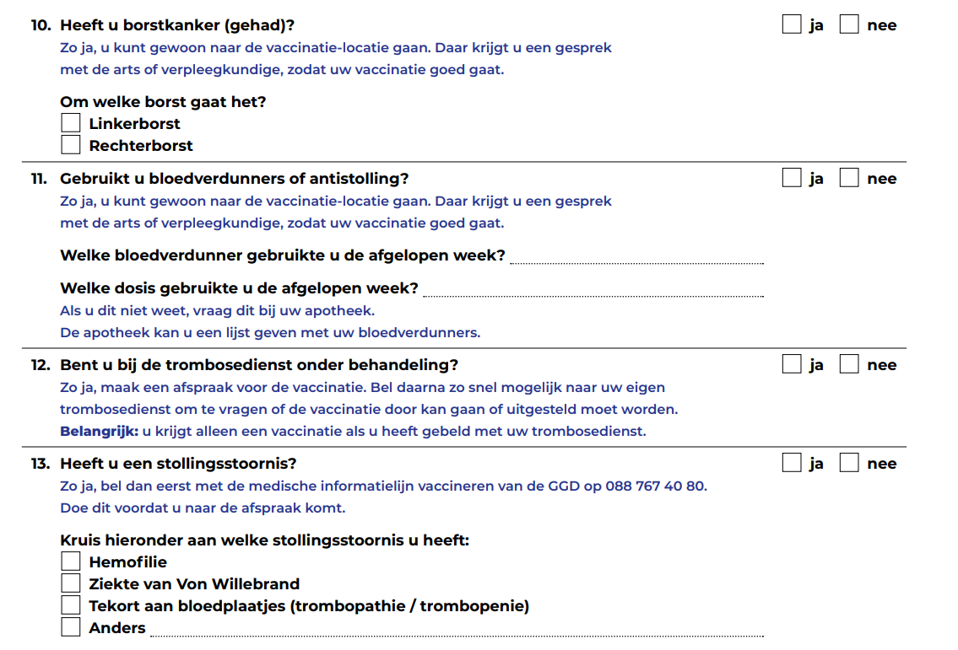

**Researcher:** What would you recommend Maria to do next?

**Participant:** Pedir um questionário em inglês. Honestamente, sim.[Ask for a questionnaire in English. Honestly, yes.]

**Researcher:** Have you ever found yourself in a similar situation?

**Participant:** Sim, porque eu fui doar sangue e eu até tenho um nível relativamente bom de holandês porque eu fiz um curso. Ok, bom. Só que na mesma nestes formulários, às vezes, o nível de holandês pode ser um bocadinho avançado. E então eu depois acabei por pedir o de inglês porque eu sabia que ia ser muito mais rápido e para não estar a usar o meu telemóvel e demorar mais tempo.[Yes, because I went to donate blood and I even have a relatively good level of Dutch because I took a course. Okay, good. But even on these forms, sometimes the level of Dutch can be a bit advanced. And so I ended up asking for the English form because I knew it would be much quicker and to not use my cell phone and take longer.]

**[STAGE 6 SLIDE 9]**

**Researcher:** “Maria asks for help from the young man behind the counter. She asks in Dutch if she can explain what is “bloedverdunners of antistolling”,  “trombosedienst onder behandeling”, and “stollingsstoornis” by pointing at the form with her finger. The young man looks surprised. She looks at the next counter, and it is empty. She looks behind, and everyone seems busy. She then tries to start a sentence a couple of times and finally says in English that these are diseases.”What would you recommend Maria to do next?

**Participant:** Pois, é assim, em último caso, se não há ninguém disponível para me ajudar, eu vou sacar o telemóvel.[Well, here's the thing, as a last resort, if there's no one available to help me, I'll pull out my cell phone.]

**Researcher:** Have you ever found yourself in a similar situation?

**Participant:** É assim, agora assim de repente, não me lembro de uma situação específica, mas eu acredito que já tenha acontecido pedir para alguém repetir ou algo assim do género e não perceber ainda ao certo, mas depois eu digo "sim, sim".[It's like this, now all of a sudden, I don't remember a specific situation, but I believe it's happened that I've asked someone to repeat [what they said] or something like it and [even after they have repeated I continue to not ] really understand, but then I say "yes, yes".]

**[STAGE 7 SLIDE 10]**

**Researcher:** “Maria turns to her phone, opens the Google Translate app, and types the words she does not understand.”In your opinion, is Maria taking a risk by using Google Translate?

**Participant:** É assim, claro, não é o ideal nesta situação porque normalmente no que toca a estas coisas eles têm sempre formulários disponíveis em inglês, normalmente, por isso é muito mais seguro, não é? Optar por o que já está feito e foi feito pelo, pronto, pelo "overheid" ou assim.[I mean, of course, it's not ideal in this situation because normally when it comes to these things they always have forms available in English, normally, so it's much safer, isn't it? To opt for what's already done and has been done by the "overheid" [authorities] or something.]

**[STAGE 8 SLIDE 11-15]**

**Researcher: “**Maria turns to her phone, opens the Google Translate app, and types the words she does not understand.”

We are going to use a scale for the following questions:

5 = to a very high degree

4 = to a high degree

3 = to a moderate degree

2 = to a low degree

1 = not at all

Is the scale clear?

**Participant:** Yes.

**Researcher:** What level of understanding do you think Maria has when using the app? Does Maria understand the text…

5 = to a very high degree

4 = to a high degree

3 = to a moderate degree

2 = to a low degree

1 = not at all

**Participant:** Eu acho que seria um 3, tendo em conta que se trata de um formulário com perguntas mesmo específicas sobre a saúde.[I think it would be a 3, given that it's a form with really specific questions about health.]

**Researcher:** What degree of risk of significant harm is Maria exposed to if using the app? Is Maria’s health at risk?

5 = to a very high degree

4 = to a high degree

3 = to a moderate degree

2 = to a low degree

1 = not at all

**Participant:** Eu diria que um 4.[I'd say a 4.]

**Researcher:** What degree of trust should Maria have in these translations? Should Maria trust these translations?

5 = to a very high degree

4 = to a high degree

3 = to a moderate degree

2 = to a low degree

1 = not at all

**Participant:** Eu diria um 3 barra 2.[I'd say a 3 or 2.]

**Researcher:** What degree of vulnerability do you think Maria has while using the app? Is Maria at risk of being vulnerable?

5 = to a very high degree

4 = to a high degree

3 = to a moderate degree

2 = to a low degree

1 = not at all

**Participant:** Diria também um 3, um 3.[I'd also say a 3, a 3.]

**Researcher:** Are there any other comments about this scenario or related scenarios you can think of?

**Participant:** Isto faz-me lembrar um pouco o meu trabalho, porque eu trabalho como enfermeira e muitas vezes eu ainda tenho que usar um pouco o Google Translate para buscar palavras para escrever nas minhas "rapportage", é assim que se diz.[This reminds me a bit of my job, because I work as a nurse and often I still have to use Google Translate a bit to look up words to write in my "rapportage"; that’s the term.]

**Researcher:** Nos relatórios?[In the reports?]

**Participant:** Sim, exatamente sobre os utentes. Já aconteceu inúmeras vezes usar uma palavra que em inglês faz sentido usar naquele contexto, mas que em holandês o Google usa exatamente a mesma palavra, mas naquele contexto não é a palavra ideal. E então os colegas às vezes perguntam o que é que querias dizer com isto mesmo? E isto tudo por causa do Google Translate, não é?[Yes, exactly about users. I've often used a word that in English makes sense in that context, but in Dutch Google uses exactly the same word, but in that context it's not the right word. And then colleagues sometimes ask what did you mean by that? And this is all because of Google Translate, isn't it?]

**Researcher:** Já agora como trabalha neste contexto e quando lida com pessoas que não sabem, que não se sentem confortáveis nem sequer com o inglês?[By the way, how do you work in this context when dealing with people who don't know, who don't even feel comfortable with English?]

**Participant:** Sim, eu conheço pessoas que usam o português.[Yes, I know people who use Portuguese.]

**Researcher:** Consigo? [With you?]

**Participant:** Sim, sim. [Yes, yes.]

**Researcher:** Isso acontece também com outras línguas? Encontra pessoas que não sei, que não se sentem confortáveis nem com o holandês, nem com o português?[Does this also happen with other languages? Do you meet people, I don't know, who don't feel comfortable with either Dutch or Portuguese?]

**Participant:** Pois, normalmente há sempre alguém. Há sempre alguém que sabe inglês e tudo mais. Sim. [Well, there's usually someone. There's always someone who knows English and everything. Yes.]

**[Training - follow-up questions – SLIDES 16-17]**

**Researcher:** Before we end the interview, we also wanted to ask you what sort of training on using these machine translation apps you would find helpful.

What type of information on machine translation would make your life easier when using these apps in health contexts?

For instance, do you feel you need more instructions on how to use the apps? Can you give us an example?

What about information about how to deal with the translations themselves? Do you have an example?

Would it be helpful to understand better the instances when machine translation is not advisable?

**Participant:** Pois para mim o ideal era que as traduções fossem as mais fiéis possíveis. E que as palavras são as adequadas naquele tipo de contexto, porque isso também pode dificultar a tradução de uma carta ou mesmo de um texto que foi escrito por um médico e eu tenho que traduzir para ter a certeza do que é que o médico disse. Por isso, sim, é mais nesse sentido, acho eu.[For me, the ideal would be for the translations to be as faithful as possible. And that the words are the right ones in that kind of context, because that can also make it difficult to translate a letter or even a text that has been written by a doctor and I have to translate to be sure of what the doctor said. So, yes, it's more along those lines, I think.]

**Researcher:** How would you like access to more information to make using these apps easier?

For instance, would you prefer to have short videos on a website or YouTube, step-by-step guides, or infographics?

Would you prefer to be offered free in-person training? And where?

If there was a website with infographics and videos explaining how to use these apps better, would you find that helpful?

**Participant:** Pessoalmente eu prefiro presencialmente porque sinto que estou muito mais atenta.[Personally, I prefer face-to-face because I feel I'm paying much more attention.]

**[Closing]**

**Researcher:** Thank you for participating in our research. Our times of analysis and publication are long, but feel free to write to us to obtain the results of this research. Otherwise, we will contact you with the results in due time.